Bloom's Taxonomy
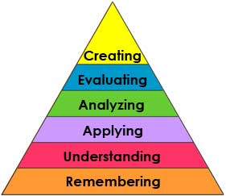  New Version | In 1956, Benjamin Bloom headed a group of educational psychologists who developed a classification of levels of intellectual behavior important in learning. During the 1990's a new group of cognitive psychologist, lead by Lorin Anderson (a former student of Bloom's), updated the taxonomy reflecting relevance to 21st century work. The graphic is a representation of the NEW verbage associated with the long familiar Bloom's Taxonomy. Note the change from Nouns to Verbs to describe the different levels of the taxonomy.  Note that the top two levels are essentially exchanged from the Old to the New version. | 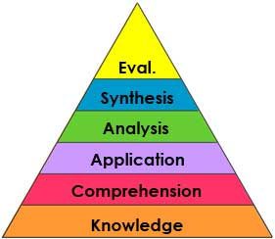  Old Version
1 = Remembering: can the student recall or remember the information? | define, duplicate, list, memorize, recall, repeat, reproduce state, recognize, retrieve, name, find
2 = Understanding: can the student explain ideas or concepts, grasp the meaning of information? | classify, describe, discuss, explain, identify, locate, recognize, report, select, translate, paraphrase, summarize, infer, compare, exemplify
3 = Applying: can the student use the information in a new way? | choose, demonstrate, dramatize, employ, illustrate, interpret, operate, schedule, sketch, solve, use, write, implement, carry out, execute.
4 = Analyzing: can the student distinguish between the different parts, breakdown information and infer to support conclusions? | appraise, compare, organize, deconstruct, outline, find, structure, integrate, contrast, criticize, differentiate, discriminate, distinguish, examine, experiment, question, test.
5 = Evaluating: can the student justify a stand or decision, judge value of ….? | check, hypothesizing, critique, experiment, detect, appraise, argue, defend, judge, select, support, value, evaluate
6 = Creating: can the student create new product or point of view? | design, assemble, construct, plan, produce, invent, devise, make, create, develop, formulate, write.
Source: Richard C. Overbaugh, Lynn Schultz
Old Dominion University: http://www.odu.edu/educ/roverbau/Bloom/blooms_taxonomy.htm

