Dear CSU Students,

We are excitedly preparing for your return to Chicago State. We cannot wait to start the year. As we actively prepare for fall semester, we recognize that this year is different than any before. You’ll find below the latest information on your classes and precautions we are all taking as we prepare for on campus registrations and classes. **If you have any questions, don’t hesitate to contact your advisor (phone and email information is** [**here**](https://www.csu.edu/provost/academicadvising.htm)**) or join our Student Townhall on August 17 from 2:00 - 3:30 (**[**RSVP here**](https://register.gotowebinar.com/register/3891806477692080143)**).**

**High-Quality, Safe In-Person Courses:** We have just posted courses that are occurring in-person on the [Course Scheduling page](https://www.csu.edu/coursebulletin/fall2020/documents/COVID19-Fall2020_Face-to-Face_Class_Schedule.pdf). **If you do not see a course on that list, it means the class will be taught by your instructor in a fully remote** environment. CSU prioritized holding courses in-person that rely heavily on learning and we will complete in-person activities before Thanksgiving. For classes occurring in person, we have outlined several precautions including requiring masks, keeping classes small, requiring social distancing in the classroom, and deep cleaning between classes.

**Health & Safety**: Let’s keep the Cougar Community safe with these four steps! Complete the COVID -19 training before coming on campus. The training is located in Moodle. Once you complete the quiz, you will receive a certificate of completion.

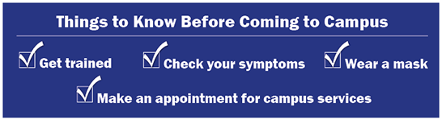

**Residence Hall:** Our residence hall will reopen. We have implemented necessary safety measures such as: limiting rooms to single-person occupancy, an additional health training, and restrictions on visitors. The resident halls will continue to build community and support learning through its programming.

**Get Ready for Classes:** Enrollment services, advising and placement exams are open and available to assist you with the application process and registration for the fall semester. Don’t forget to make an appointment!

* Advisors can assist with selecting courses or registering for classes (contact information [here](https://www.csu.edu/provost/academicadvising.htm)).
* Financial aid can assist with your financial aid plan. Make an appointment by emailing [csu-finaid@csu.edu](mailto:csu-finaid@csu.edu).
* The Bursar can help you with textbook vouchers. Make an appointment by emailing bursar@csu.edu.
* Bookstore is now virtual (<https://www.bkstr.com/chicagostatestore/home>).
* IDs are available in the library by appointment (call 773-995-3286).

**If you have any questions, don’t hesitate to contact your advisor (phone and email information is** [**here**](https://www.csu.edu/provost/academicadvising.htm)**) or join our Student Townhall on August 17 from 2:00 - 3:30 (**[**RSVP here**](https://register.gotowebinar.com/register/3891806477692080143)**).**